

This is the starting page of the Database Management System record website.

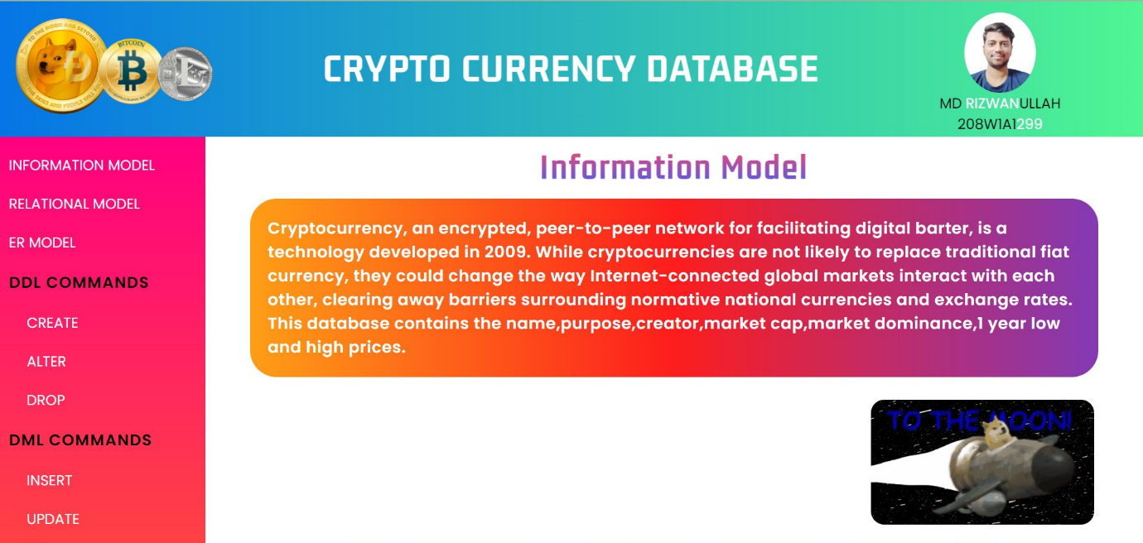

Information Model of the crypto currency database it contains the purpose of the website.

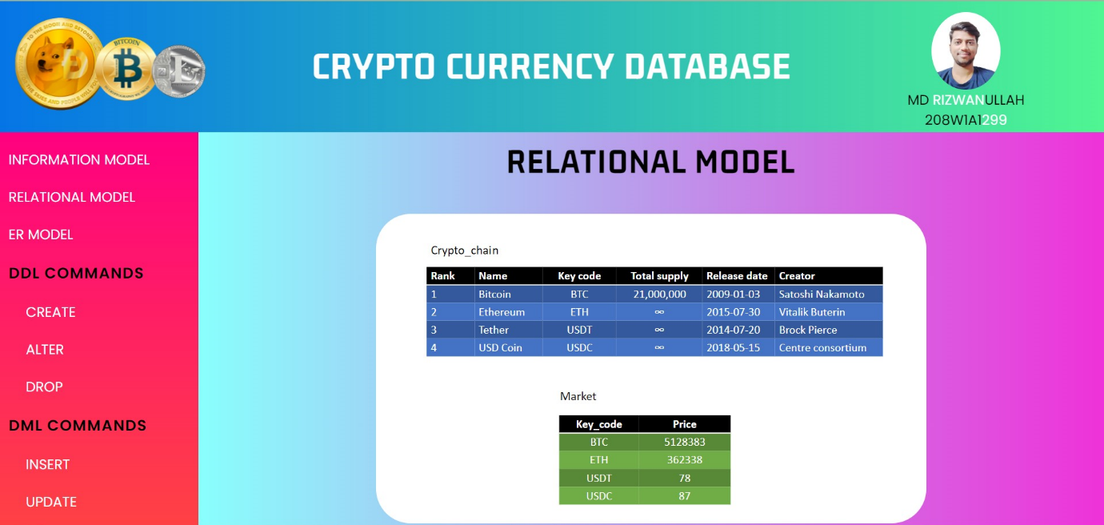

Relational Model of the crypto currency database it contains the tables used in database and relation between them.

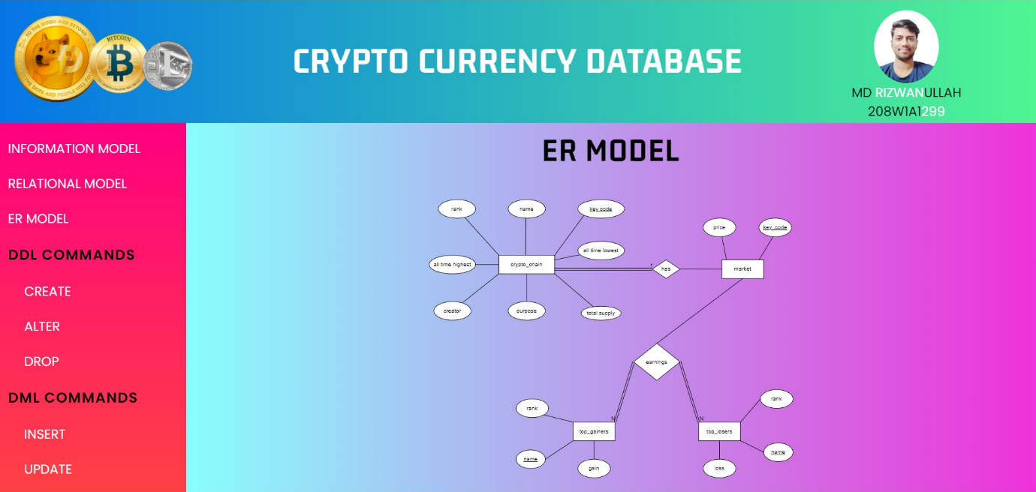Entity relation model of crypto currency database contains the relationship between the entities used.

Create command is used here in crypto currency database to create an empty database.

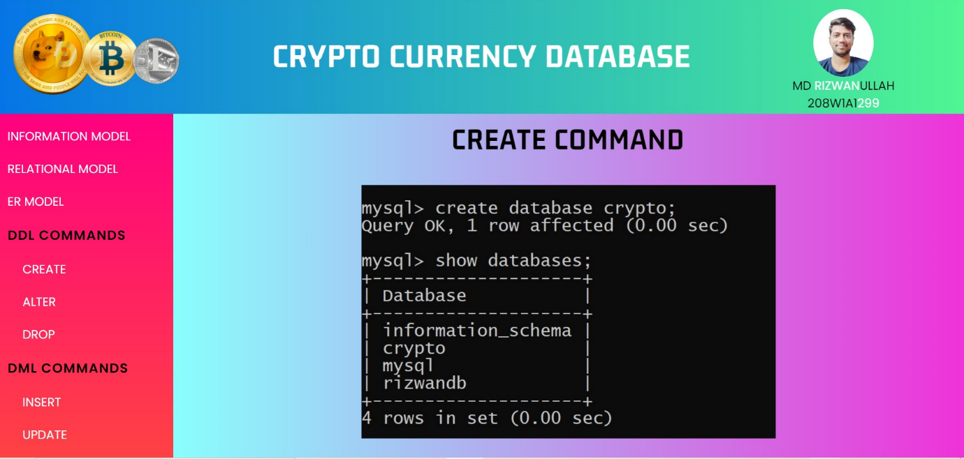

Create command is used here in crypto currency database to create tables with our custom column names.

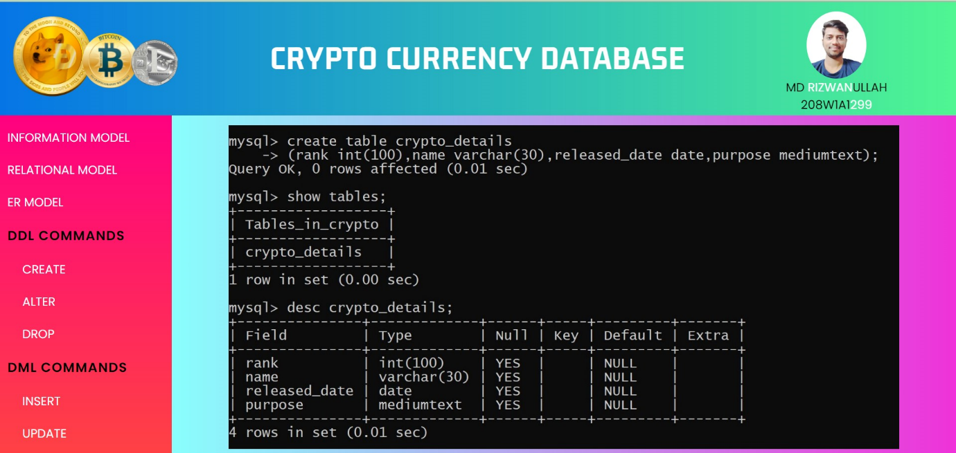

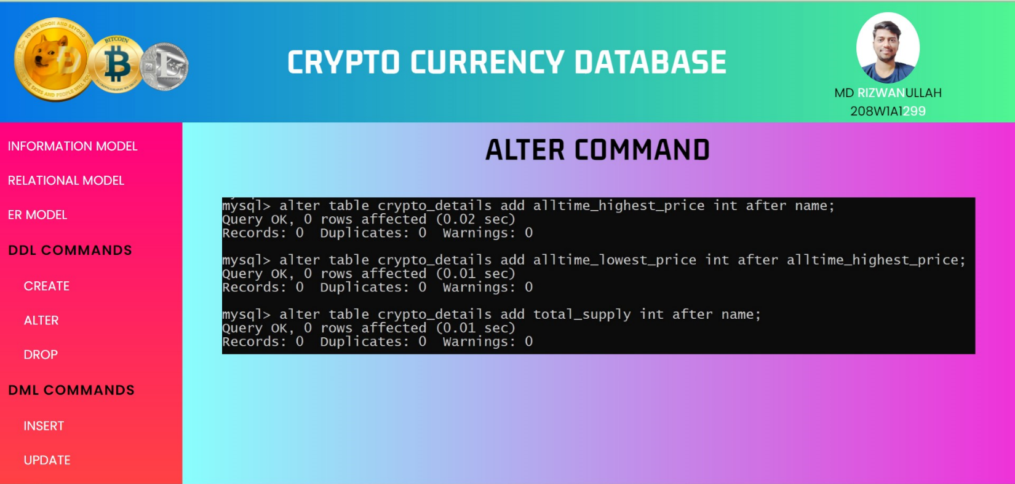

Alter command is used here in crypto currency database to change the skeleton structure or column names in table.

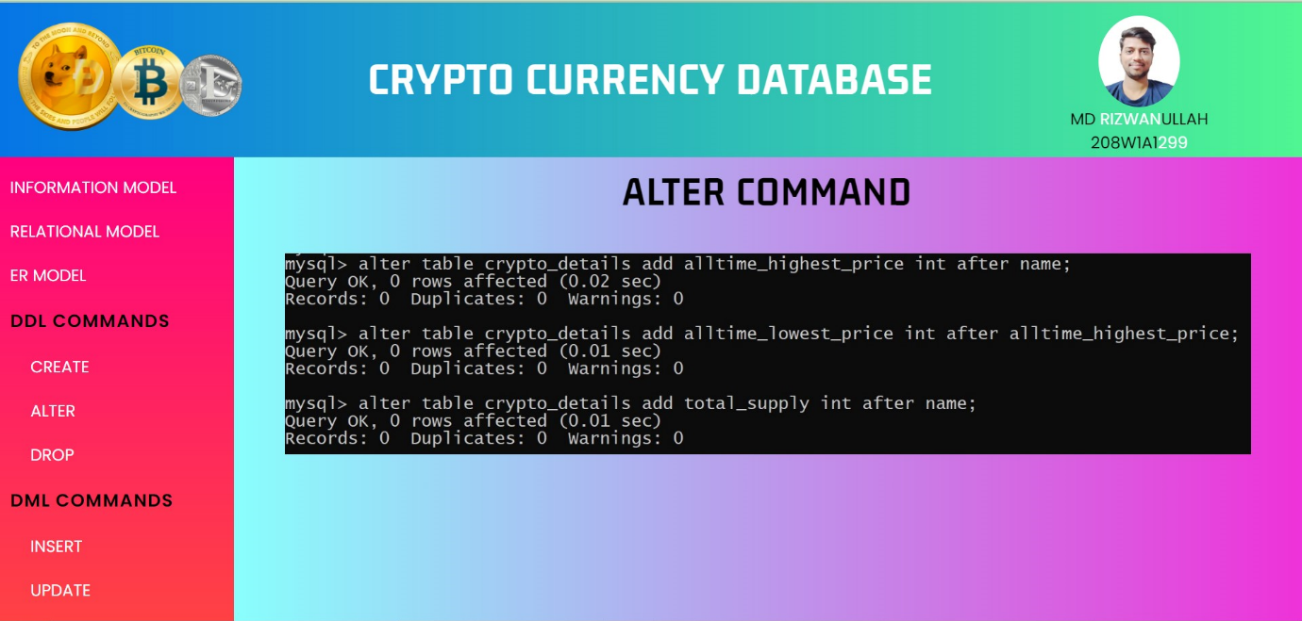

Continuation of alter commands with some additional changes in skeleton.

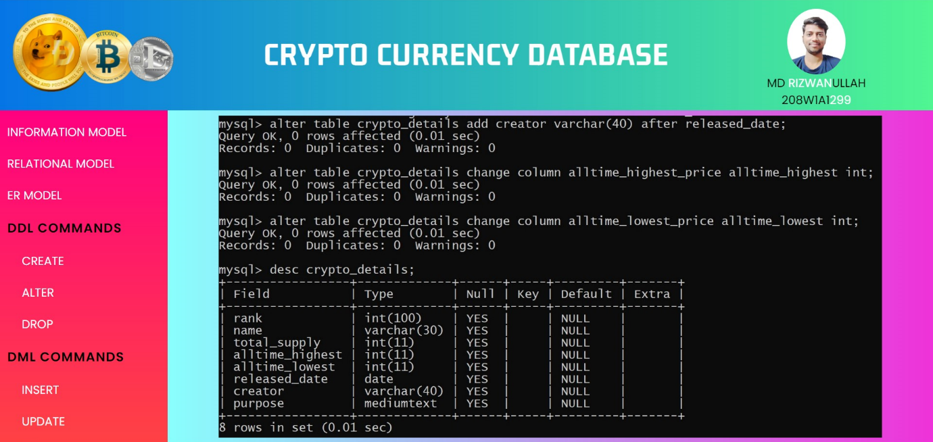

Drop command is used here in crypto currency database to remove unwanted tables or some not needed databases.

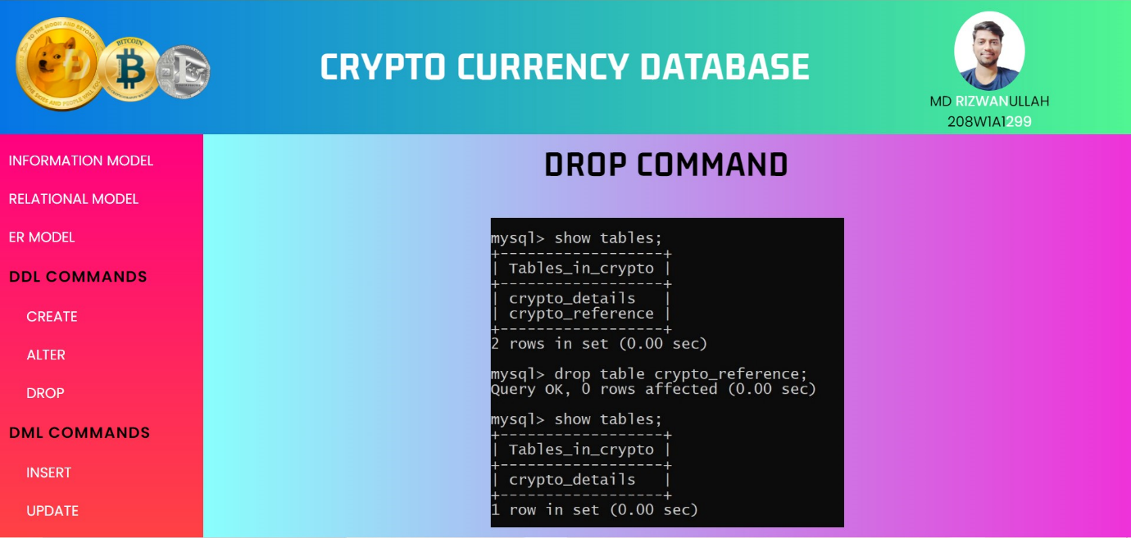

Insert command is used here in crypto currency database to insert the values to the database tables.

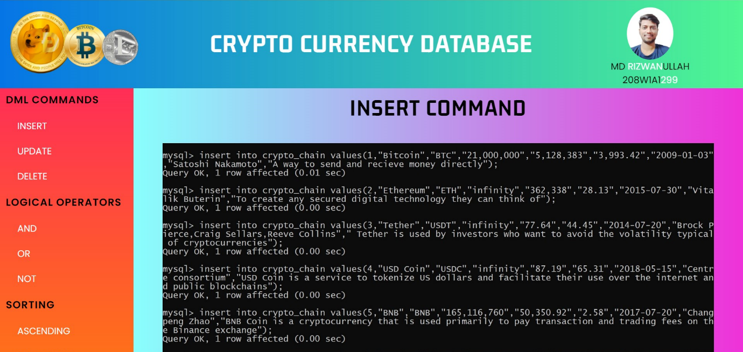

Continuation of some insert commands for adding some more data to the tables.

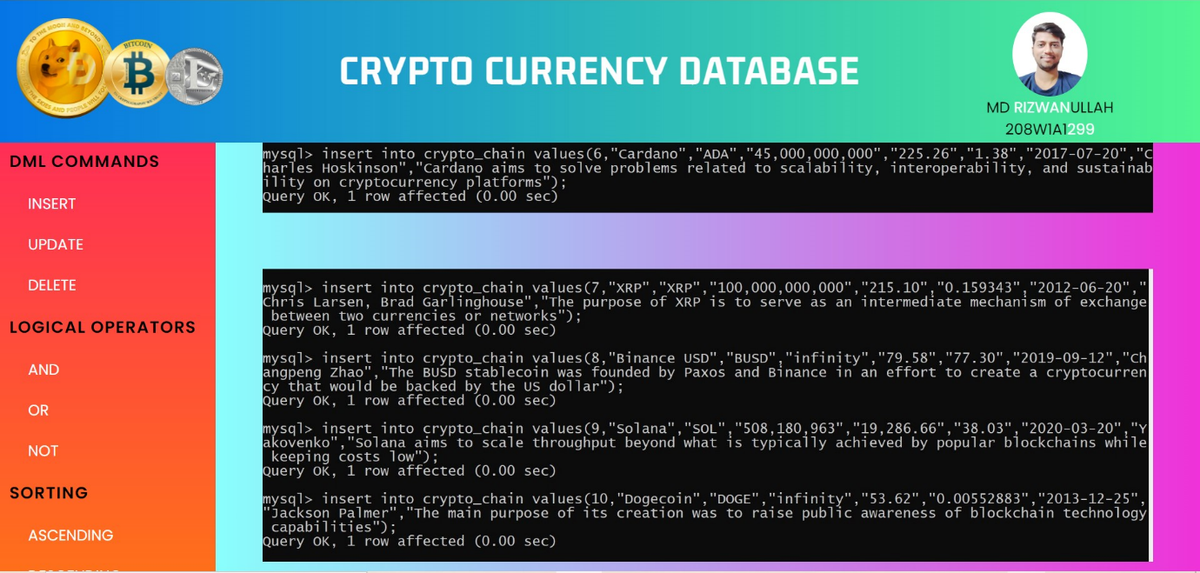

Viewing the entered data in the table using select command.

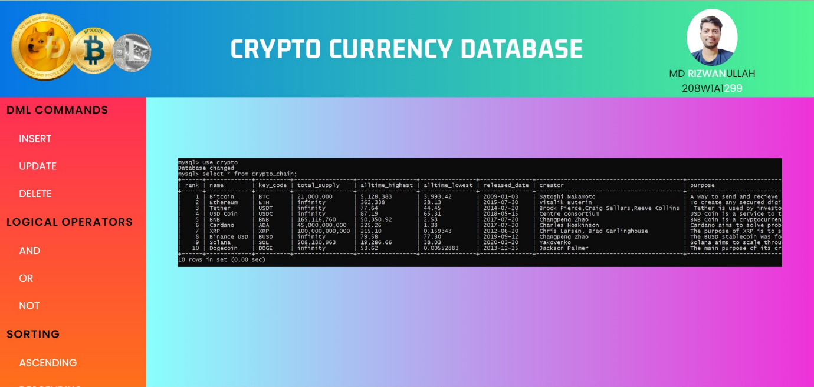

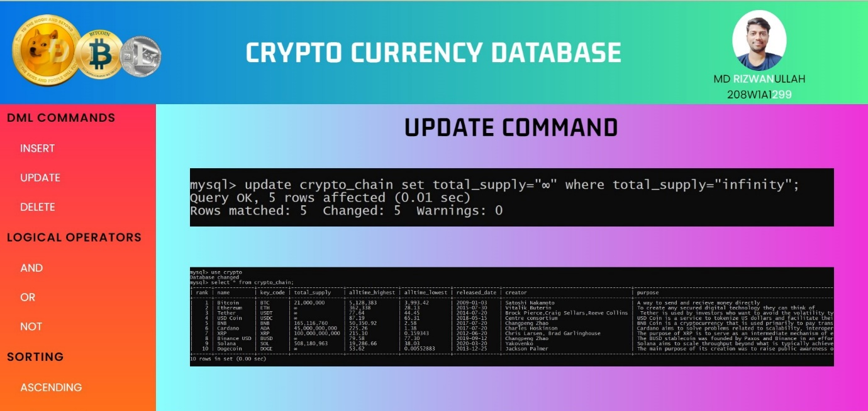

Update command is used here to update some specific data with specific values in it.

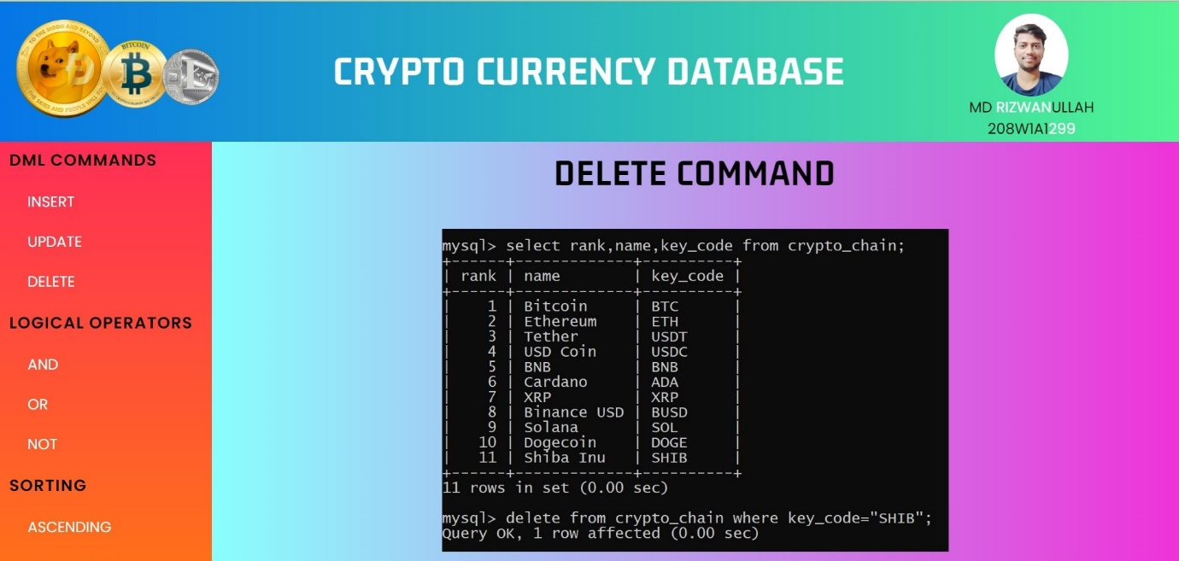

Delete command is used here to delete the three columns namely rank,name,key_code.

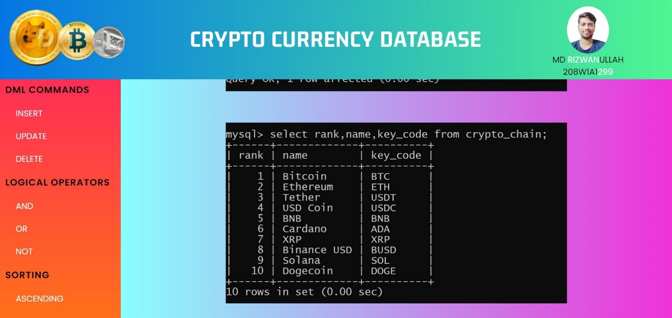

Viewing the table with the help of select command after deleting the columns above.

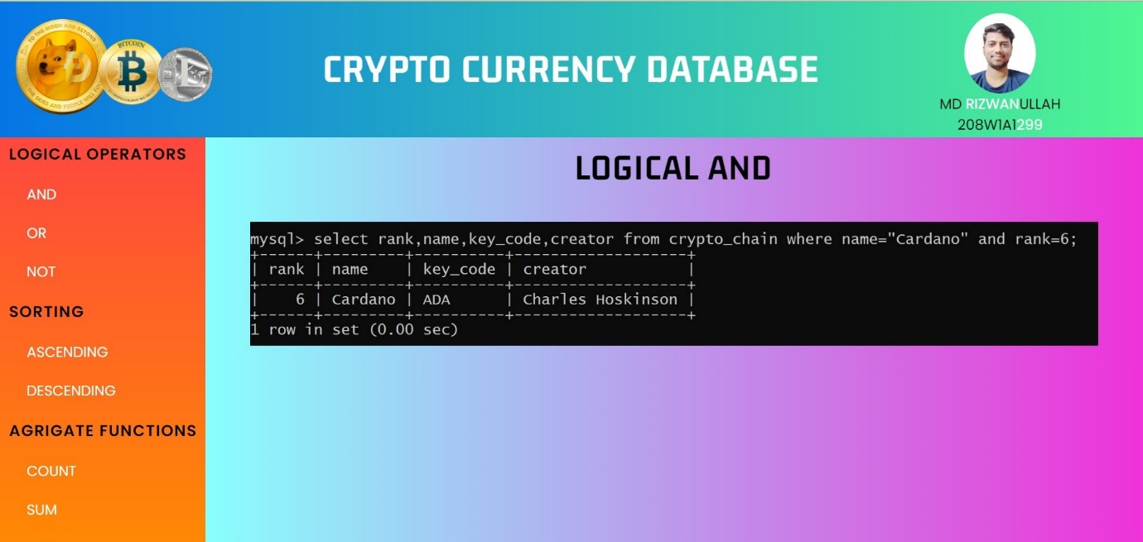

Logical AND is used here to viewing the data which has both the field values in it given here in the command.

Logical OR is used here to viewing the data which either of the values in it given here in the command.

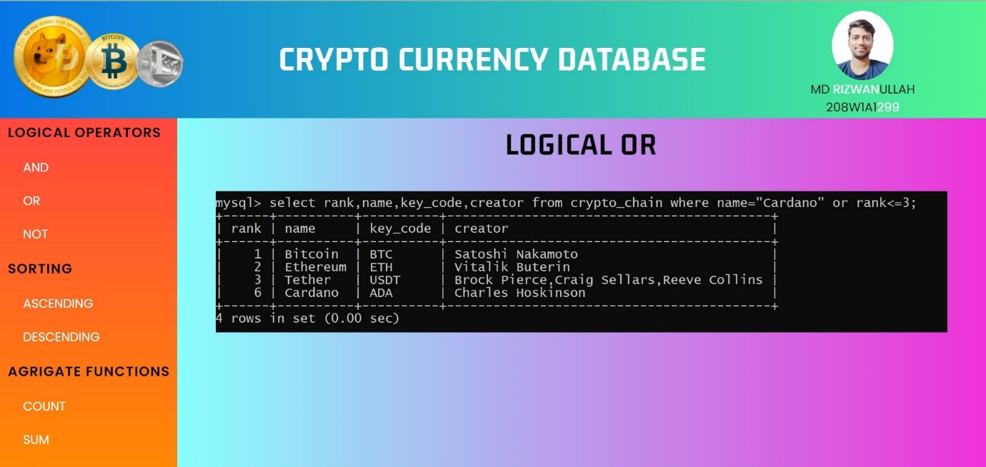

Logical NOT is used here to view the data except the rows with has the value specified here in this command.

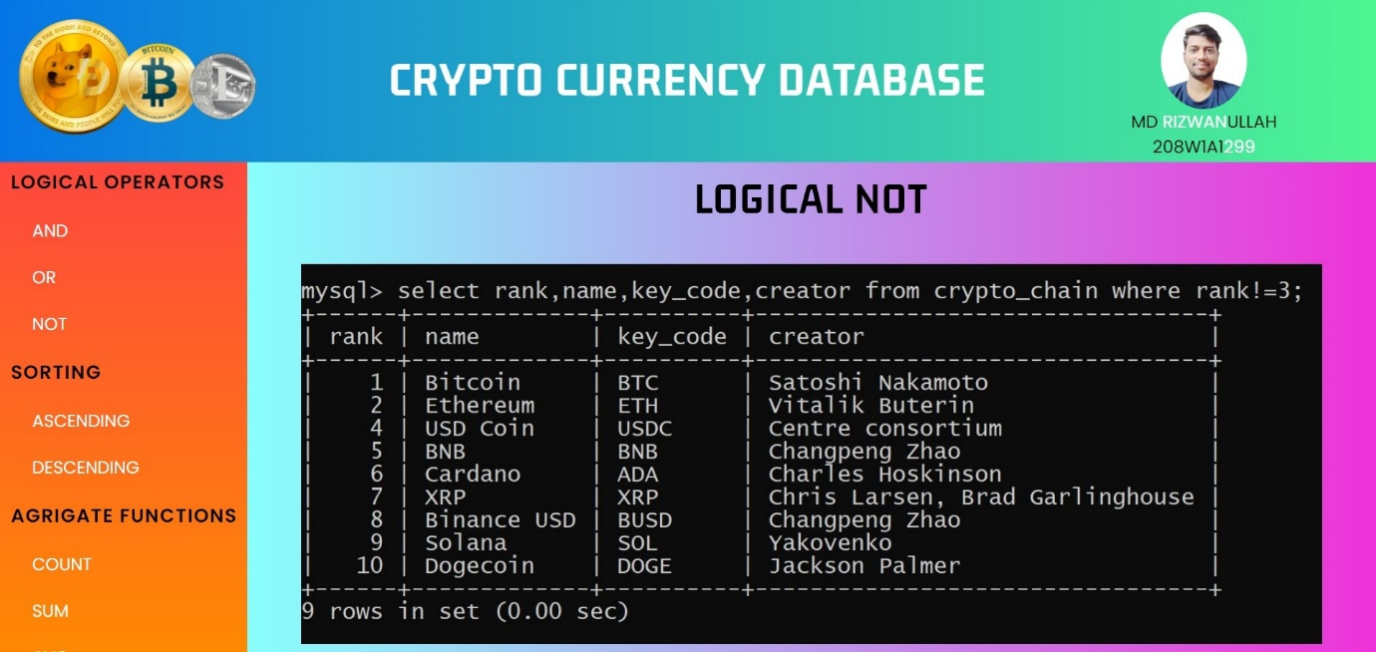

Viewing the data of the table before applying the operations on it with the help of select command.

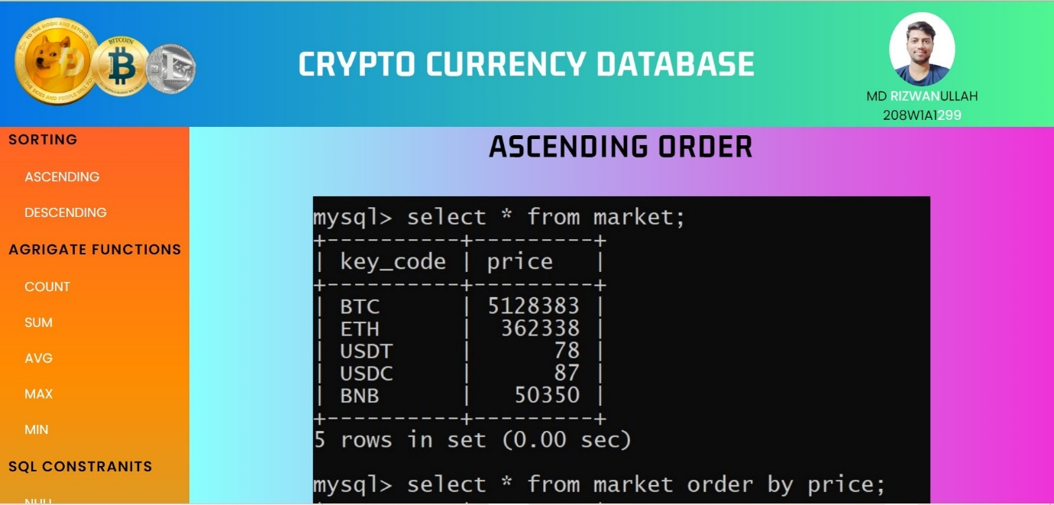

Order by is used here to sort any column data here in ascending order ( small to big ).

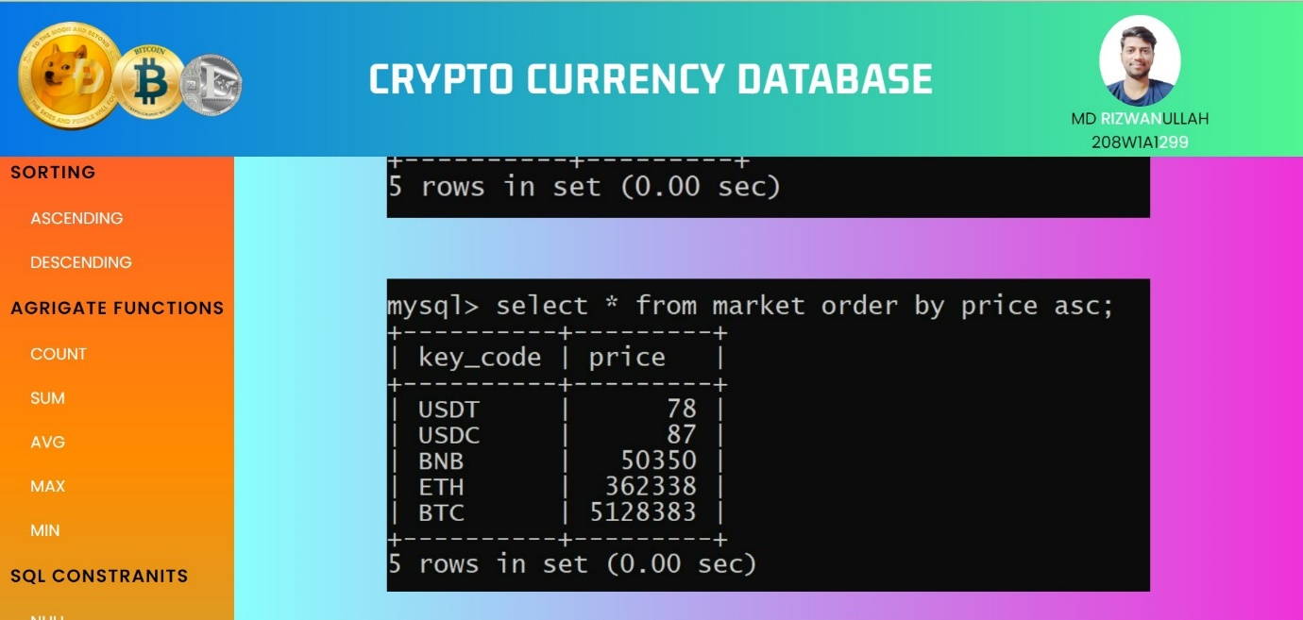

Viewing the data in the table using select command before applying any operations on it.

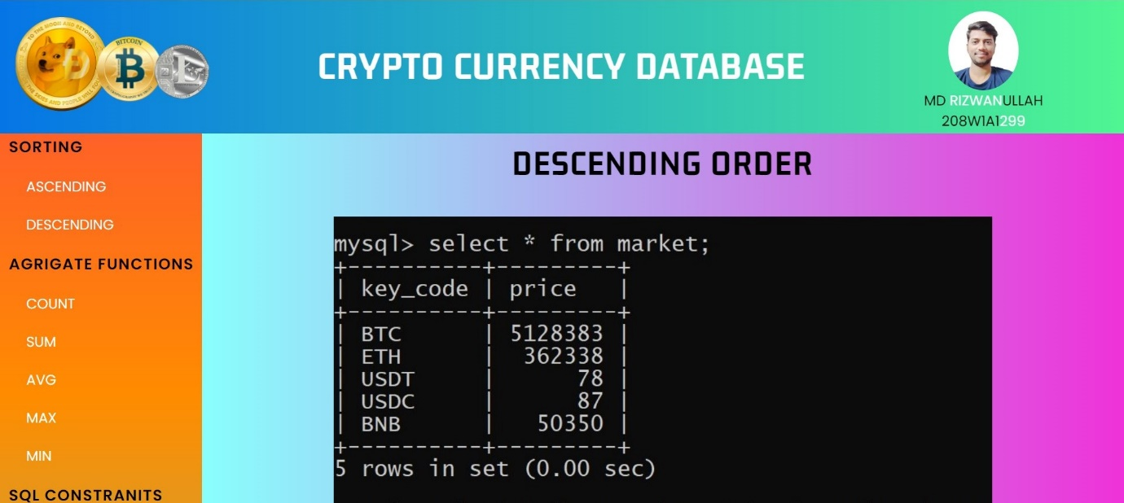

Order by is used here to sort the column data in descending order ( big to small ).

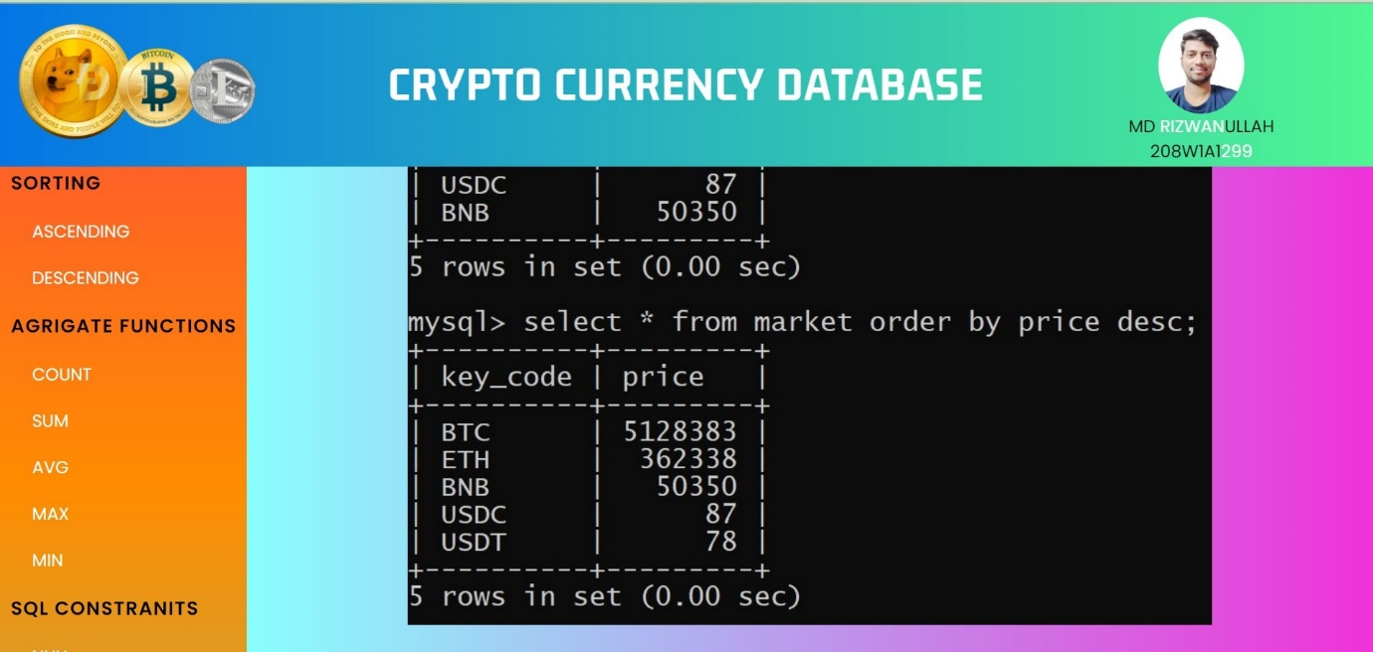

Count operator is used here to count the number of rows of data which matches the constraint given by us in the command.

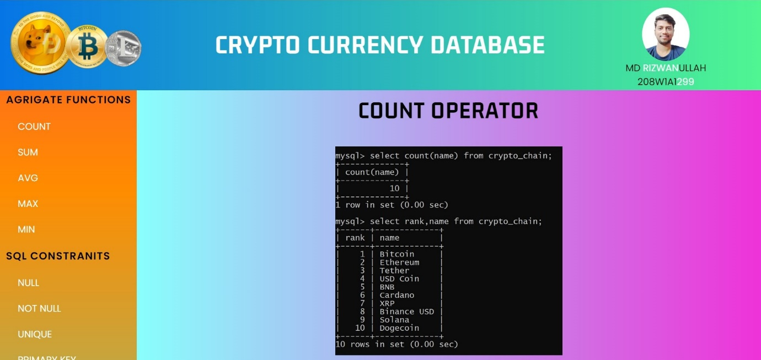

Sum operator is used here to calculate the sum of the values of the given column in the command.

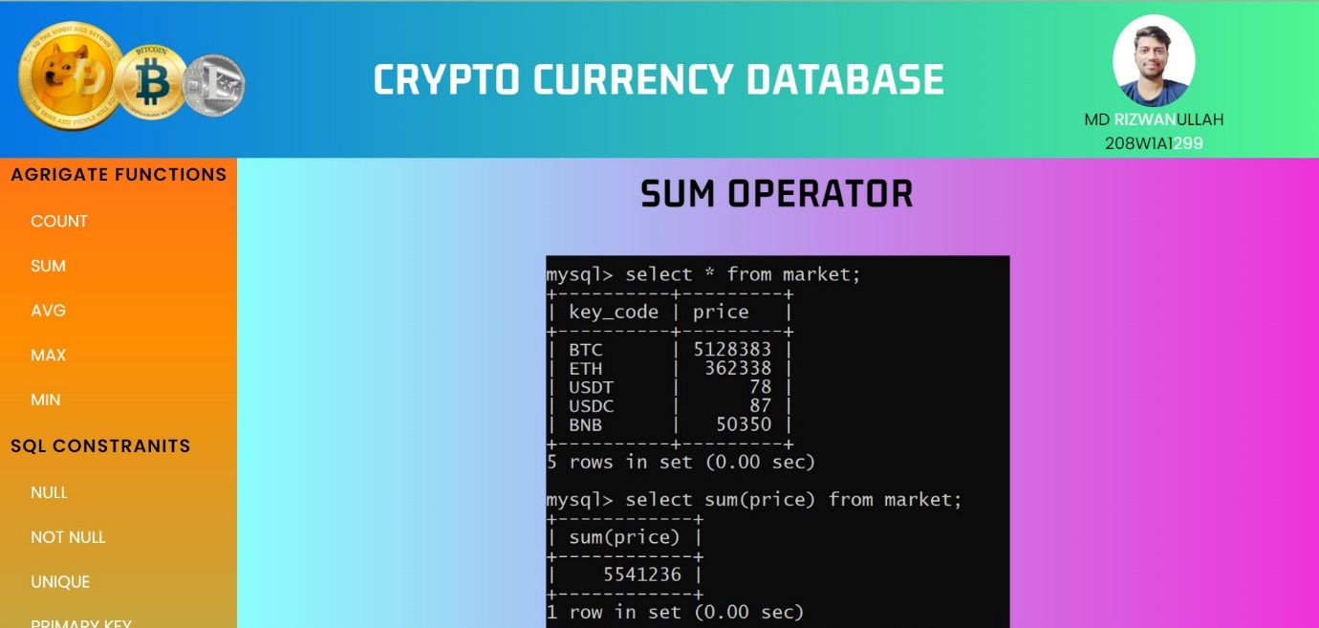

Average operator is used here to calculate the average of the values of the given column in the table.

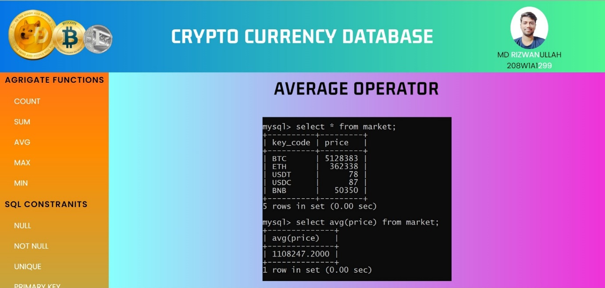

Max operator is used here to find the maximum of the values of the given column in the table.

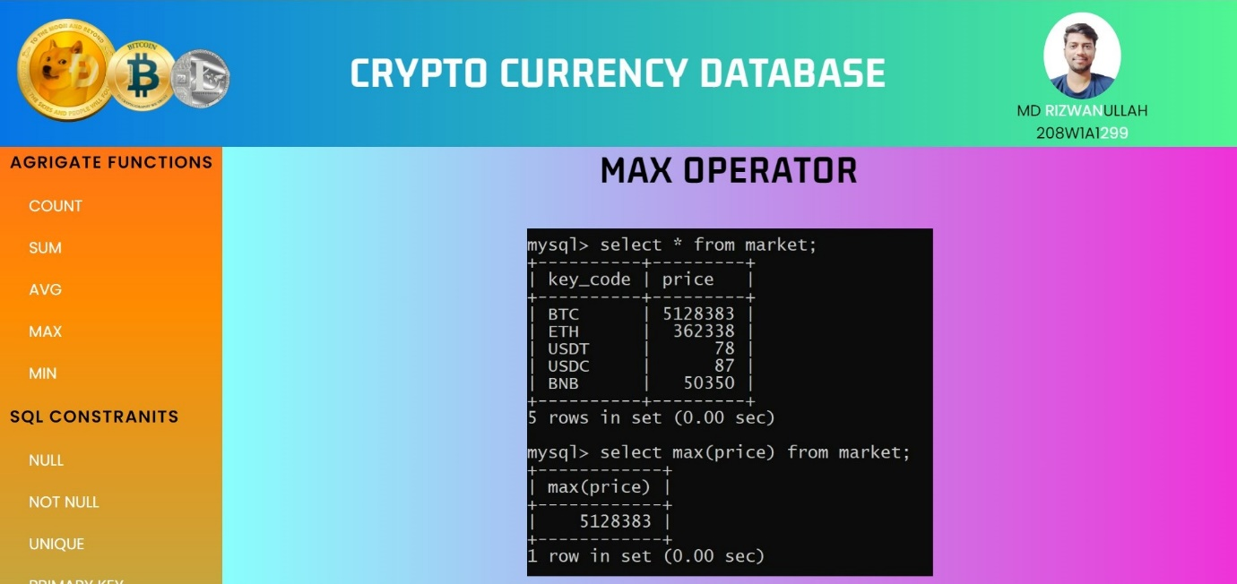

Min operator is used here to find the minimum of the values of the given column in the table.

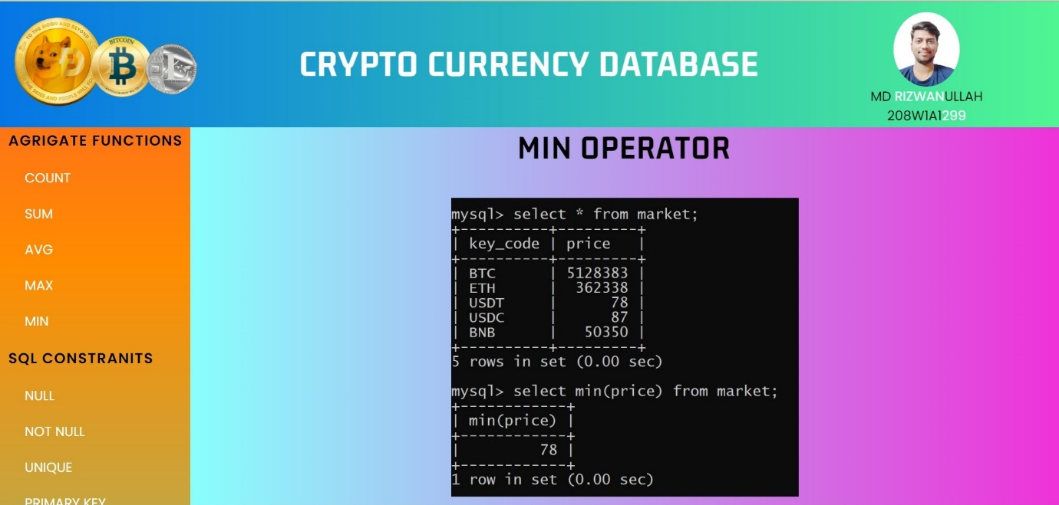

Null Constraint is used to allow any null values in the column of the table.

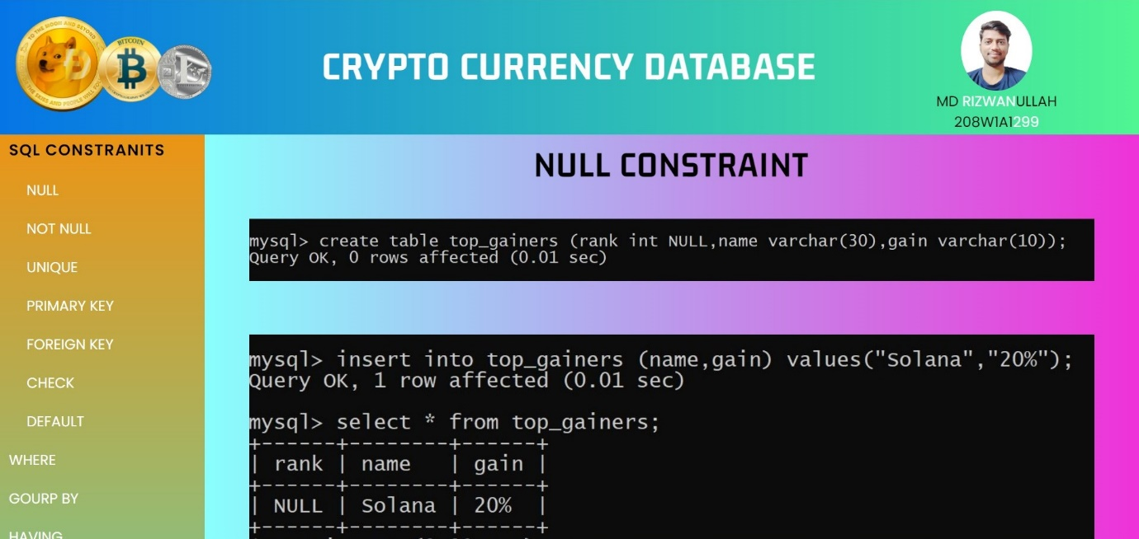

Not Null Constraint is used for not allowing any null values in the column of the table.

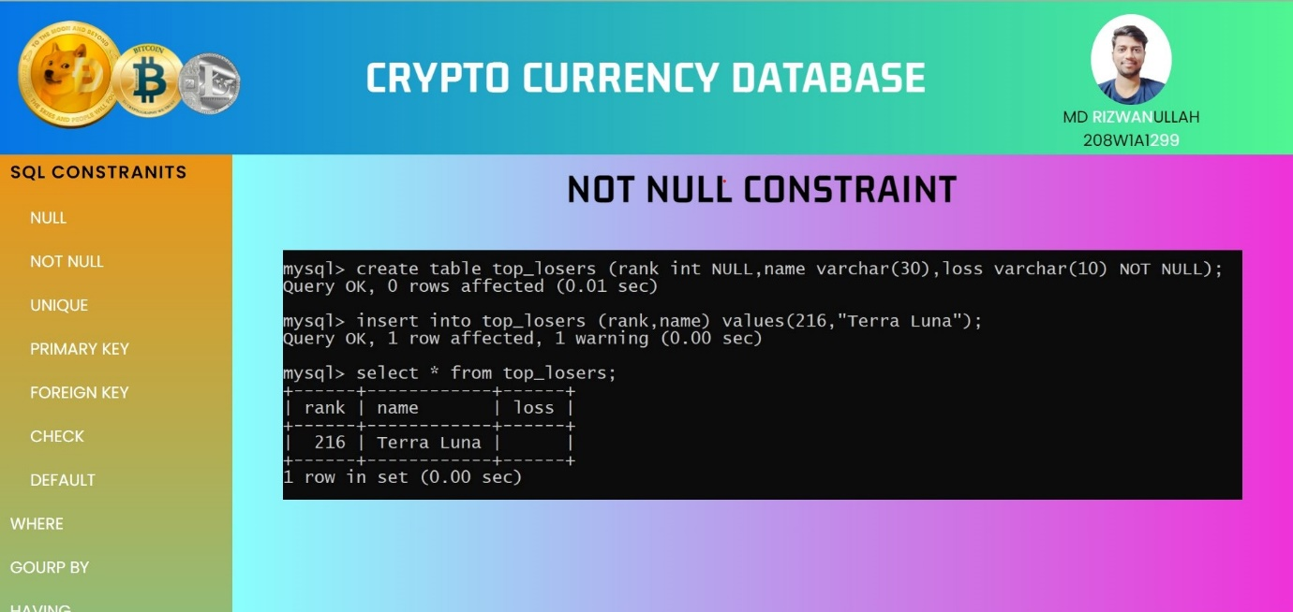

Unique Constraint is used to allow only unique values in the column of the table.

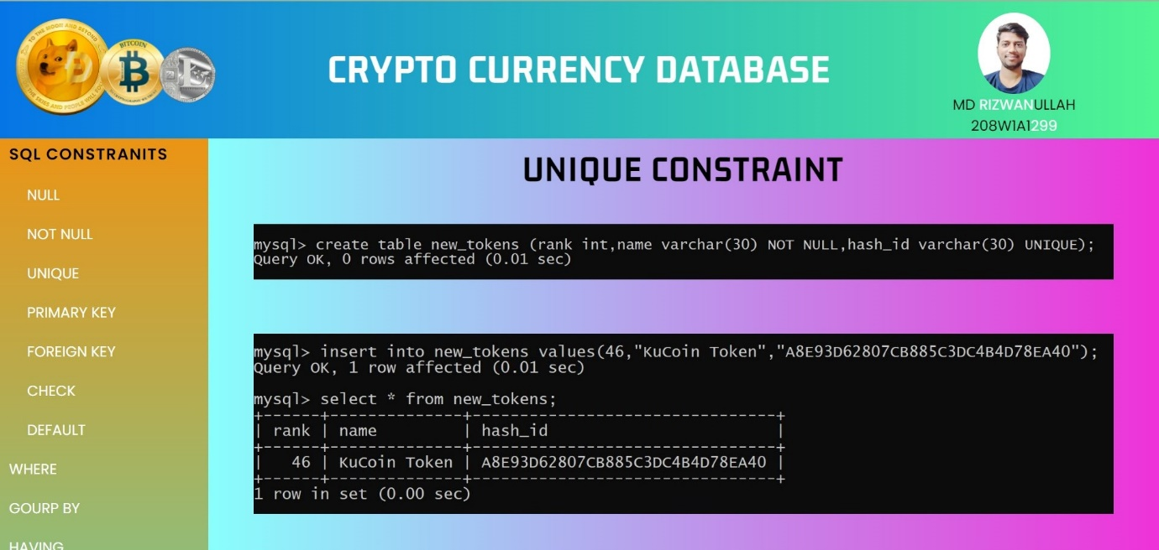

Primary Key is combination of unique and not null constraints it has unique values and no null values in it.

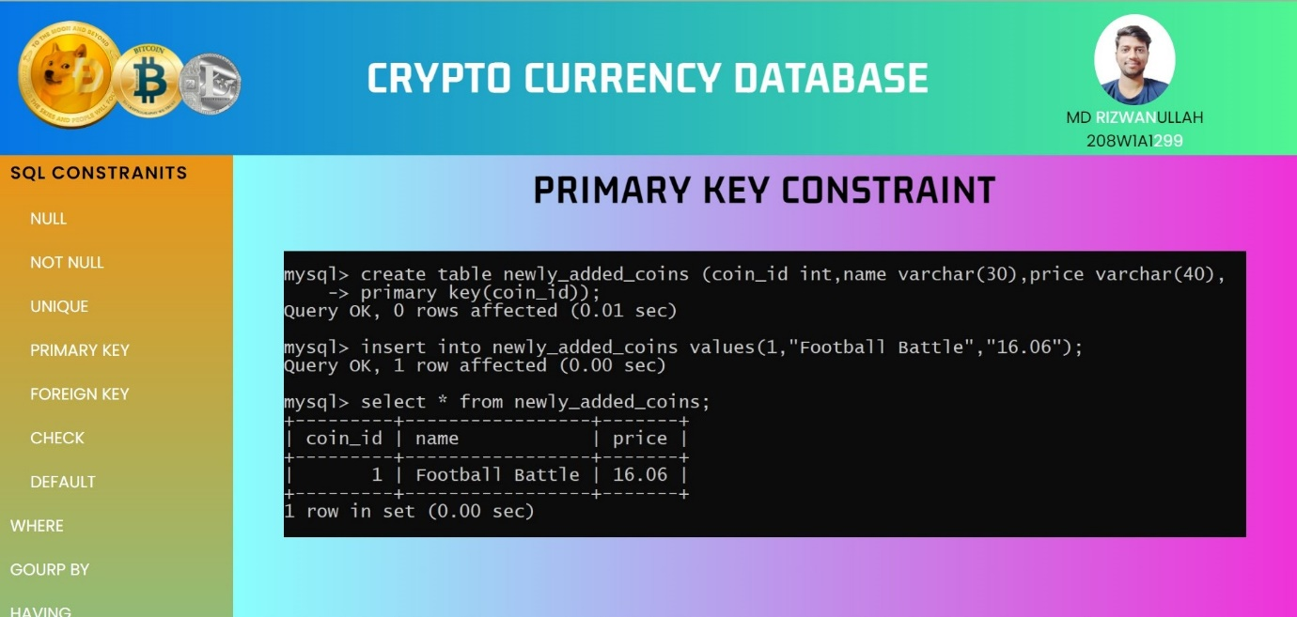

Using Foreign Key and connecting it with the primary key of other table and checking the primary keys in the table with the help of desc commad.

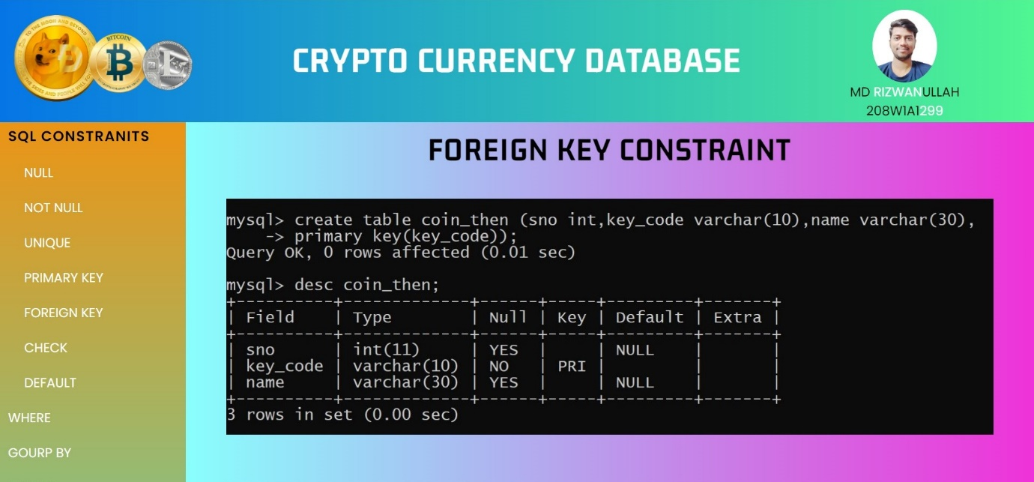

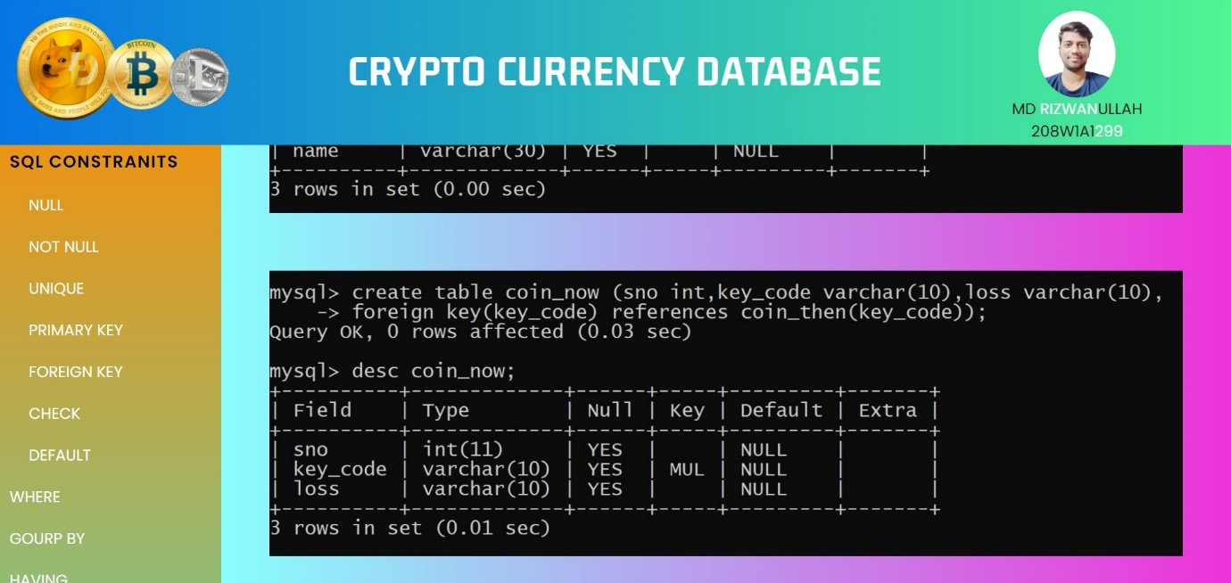

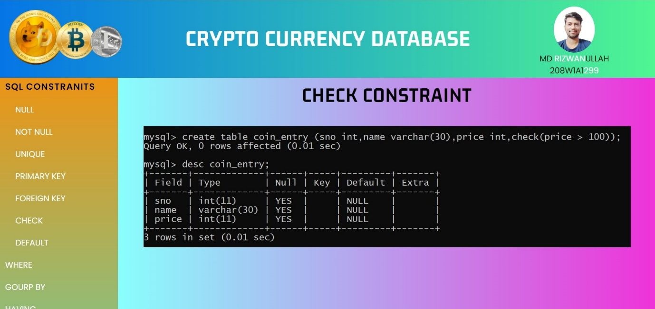

Check Constraint is used to check the inserted values before adding it in the table of the database.

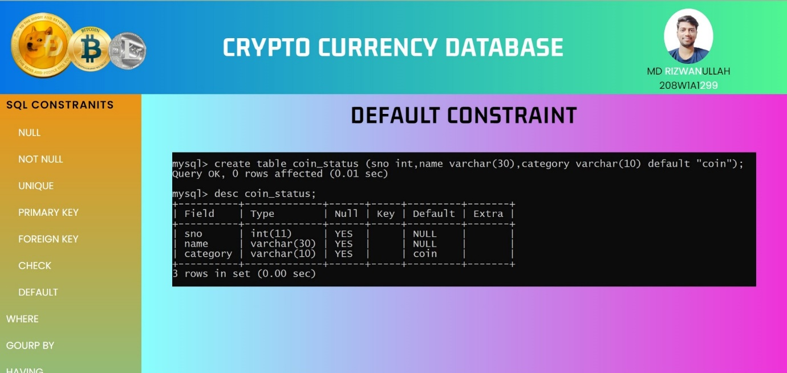

Default Constraint is used to show some default value if noting was inserted in the column field.

Where command is used here to add some extra conditions in viewing the data of the table.

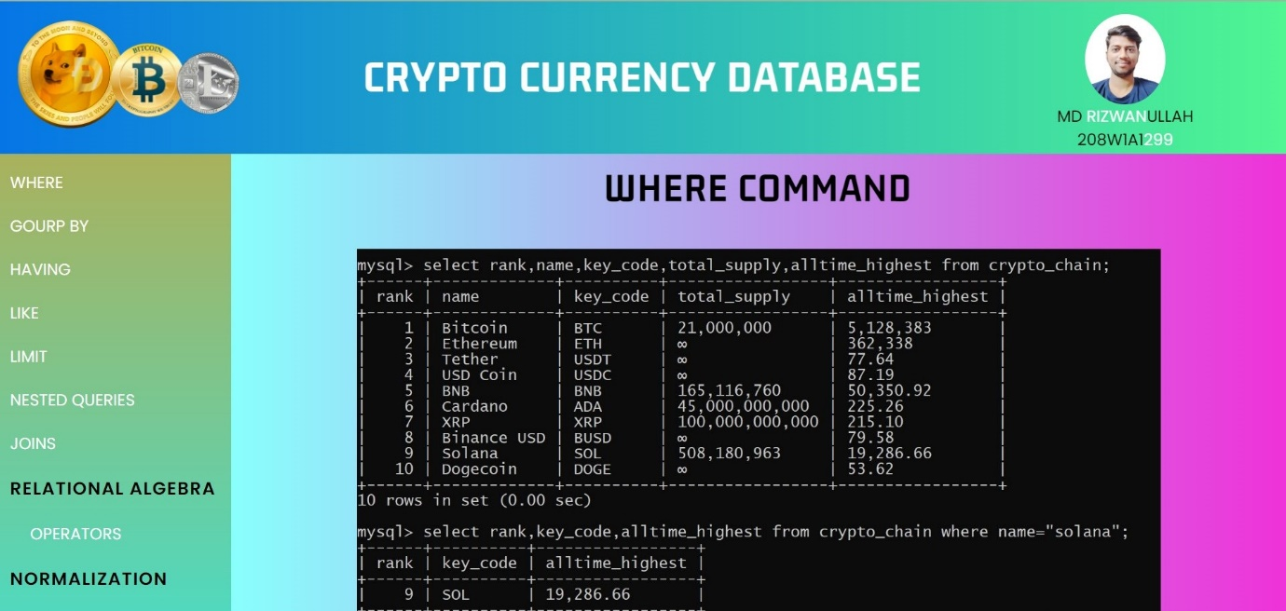

Viewing the data using select command before applying any operations on it.

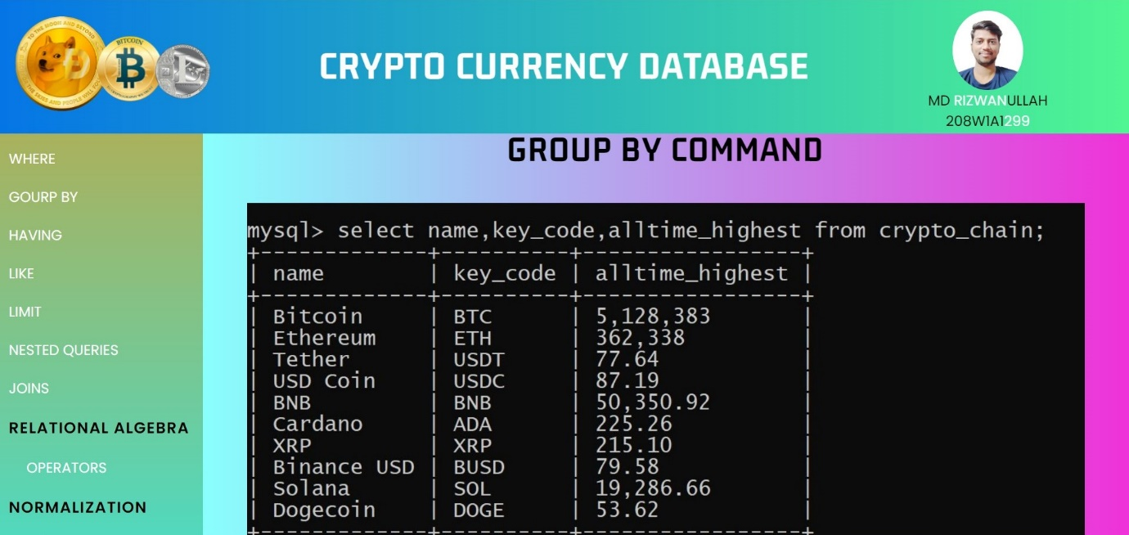

Group By command is used to group some columns together and view the data of the table.

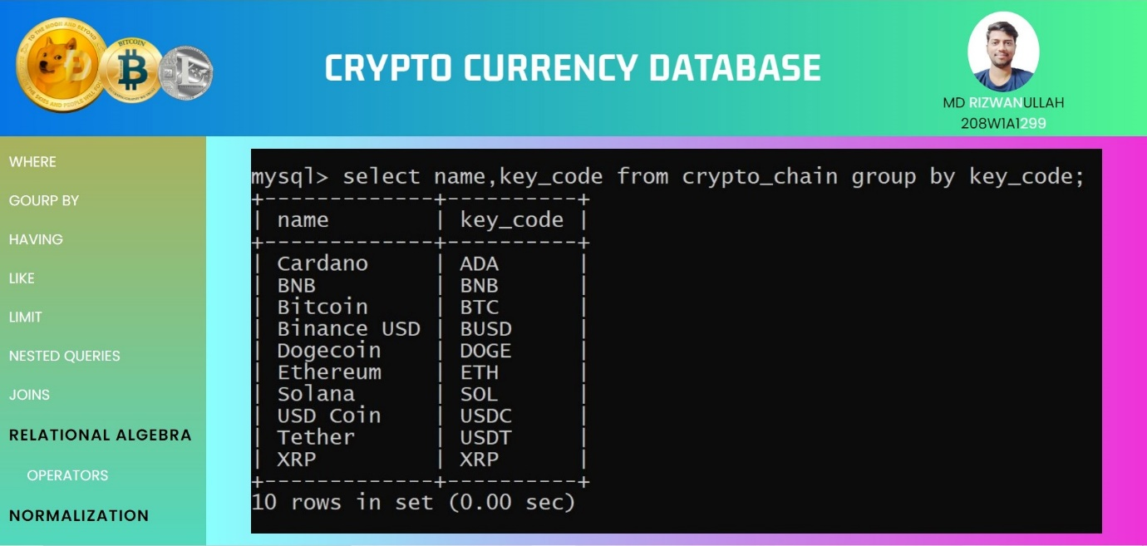

Having is just like where command but here it is used before we have used group by here .

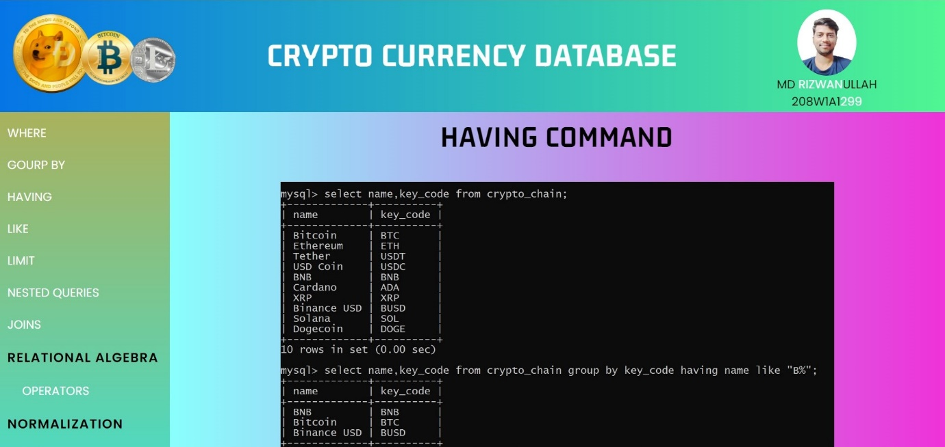

Viewing the table data using select command before applying any operations on it.

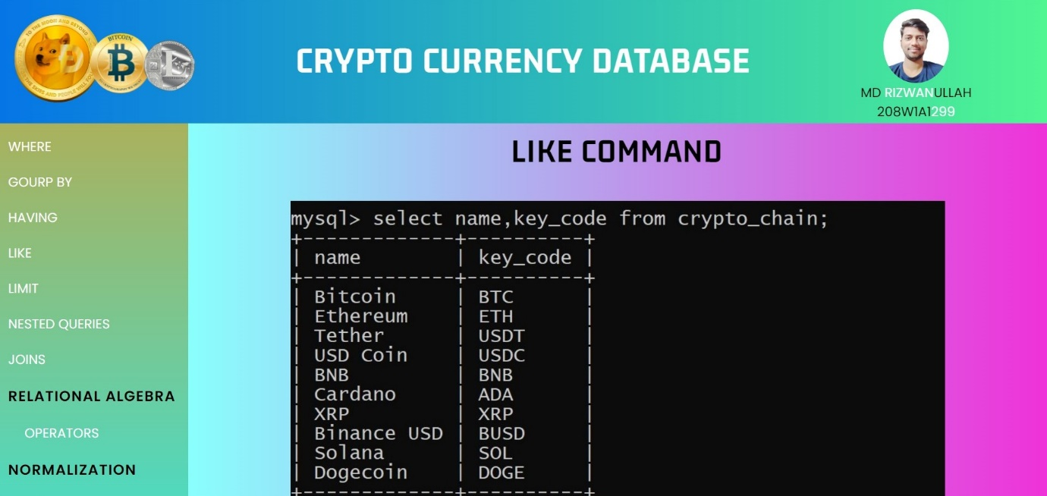

Like command Is used to view the data of the table if they have the few hints we are providing in the command.

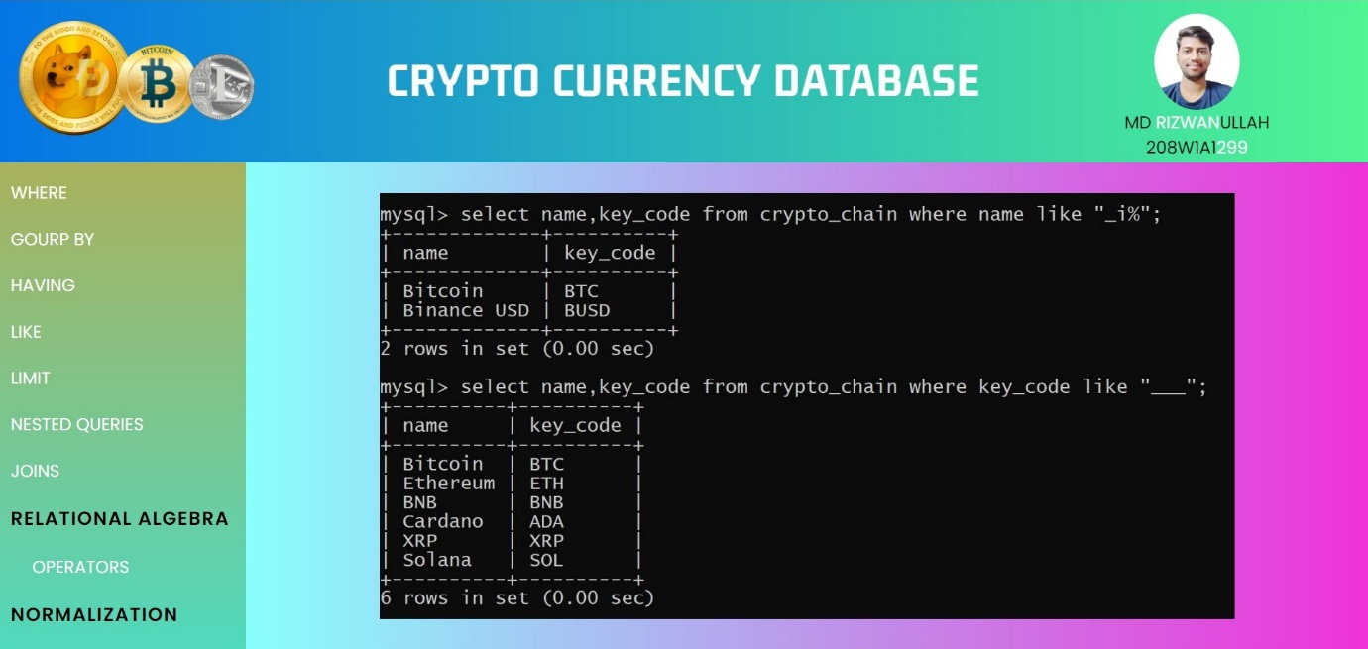

Viewing the table data using select command before applying any operations on it.

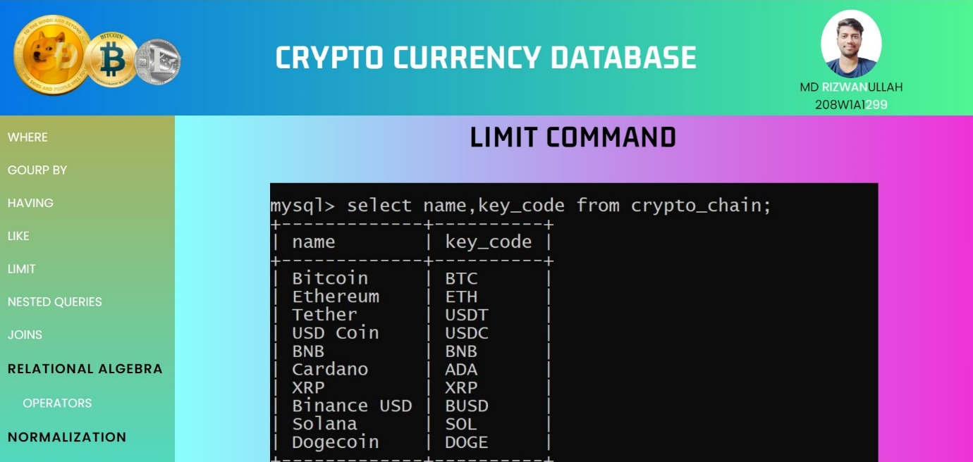

Limit command is used to view only certain not of rows in a bunch of rows which satisfy the given constraint in the command.

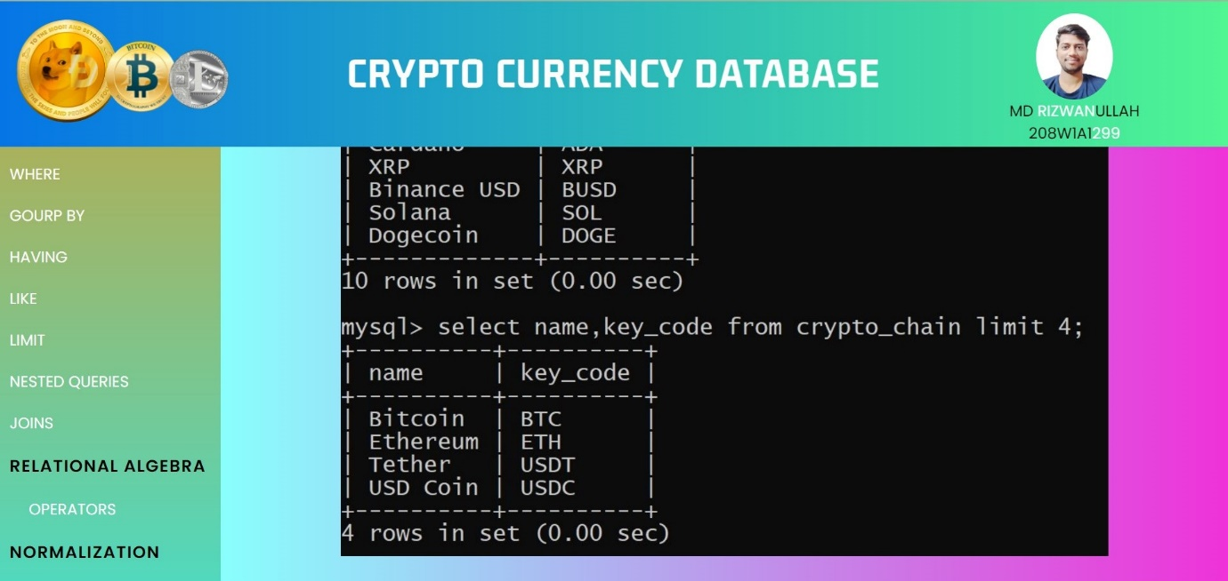

Viewing the table data using select command before applying any operations on it.

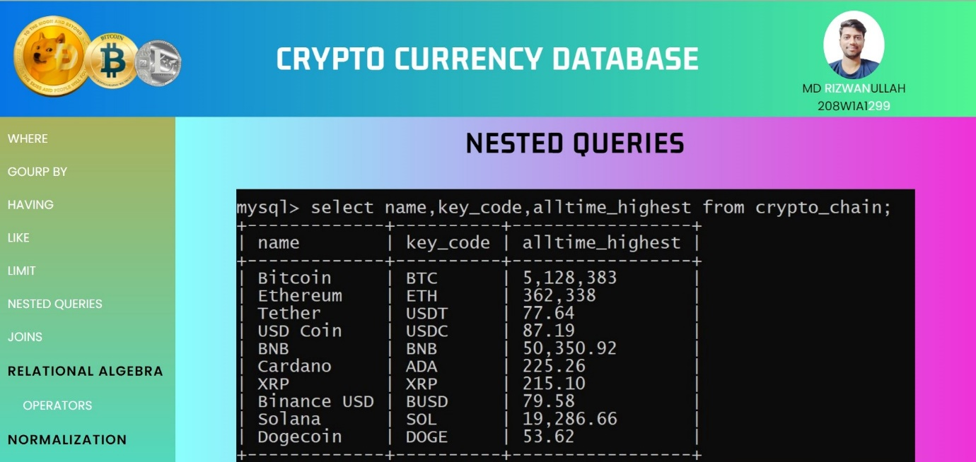

Nested queries are used here to join two or more table with query inside query to get the satisfied values from both the tables.

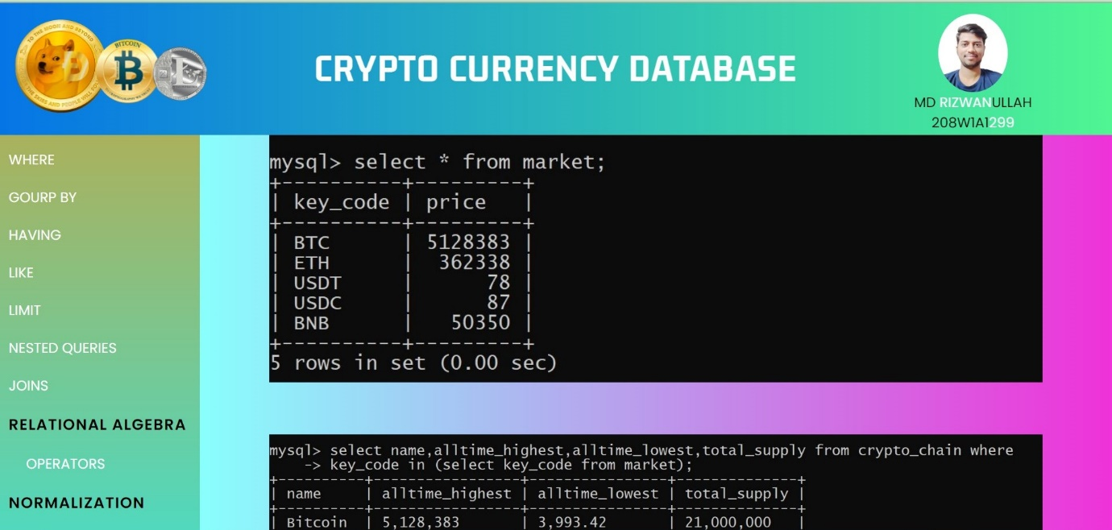

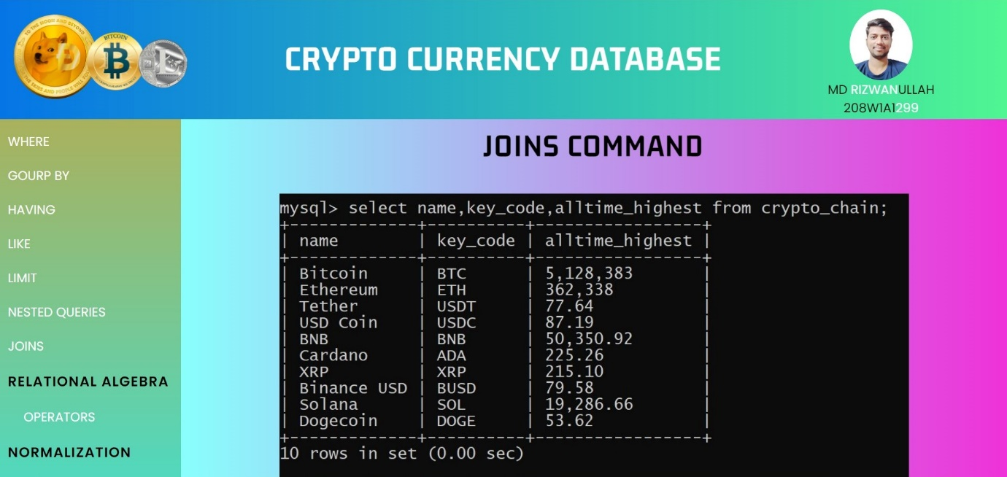Viewing the data of the table using select command before applying any operations on it.

Joins is the advanced and simpler version of the nested queries it make easy to work when we have two or more tables.

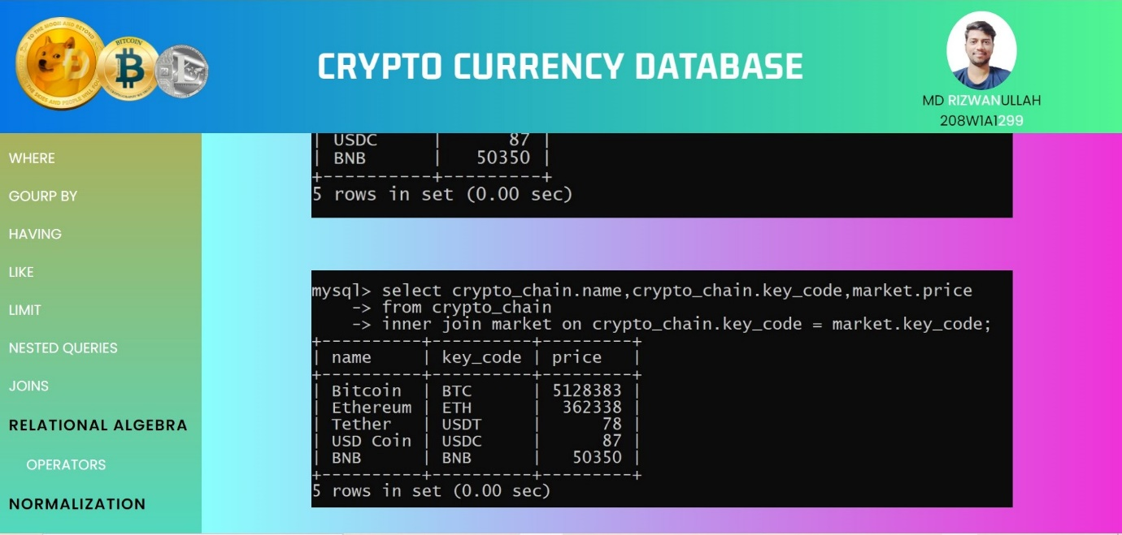

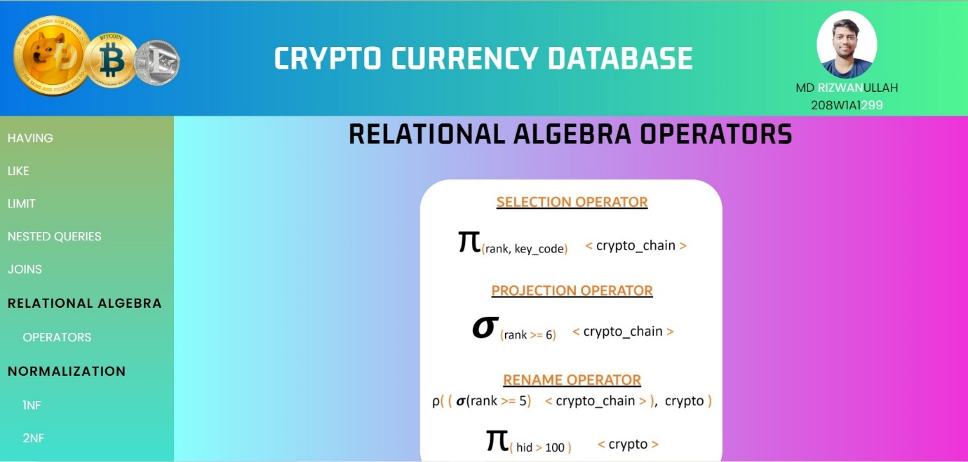Relational Algebra Concept it is not practical but just a representation of queries.

Normalizing the table to 1NF to remove anomalies in the future insertion of data in the table.

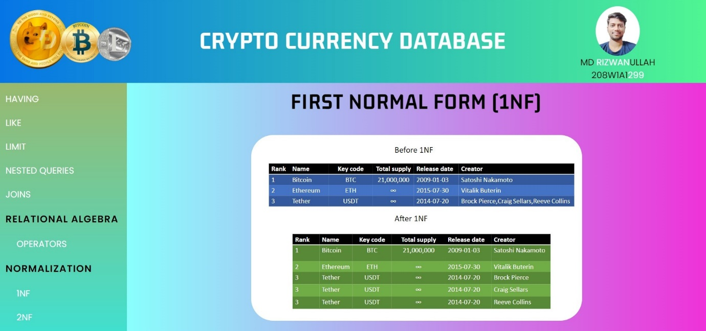

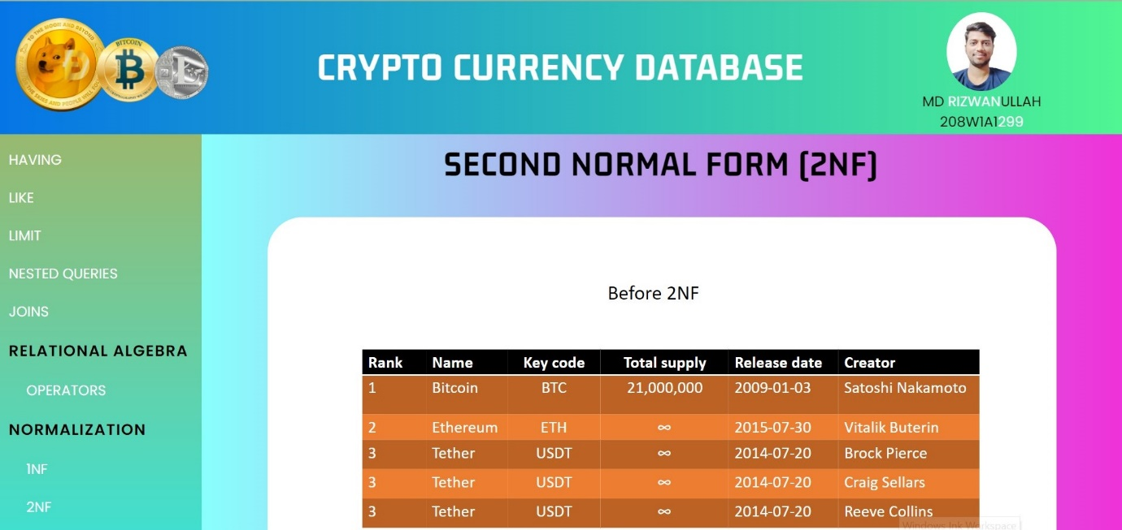Table before 2NF having some problems of normalization in it.

Normalizing the table to 2NF to remove anomalies in the future insertion of data in the table.

